Final Lab Task 2: Transforming ER Model to Relational Tables

Name: Halili, Cassandra M.

BSIS-I102

Task 1. Student Table:

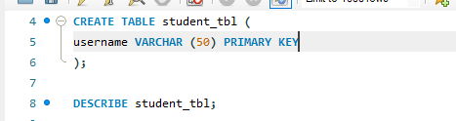

Task 1: Table Structure

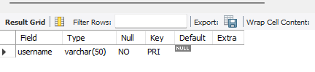

Task 2. Assignment Table:

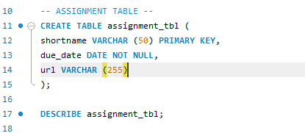

Task 2. Table Structure:

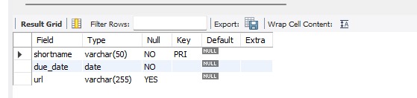

Task 3. Submission Table:

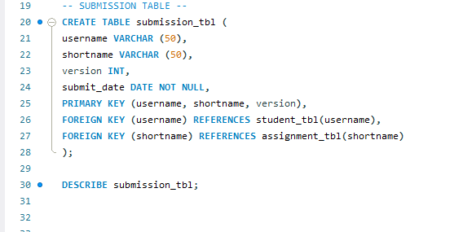

Task 3. Table Structure

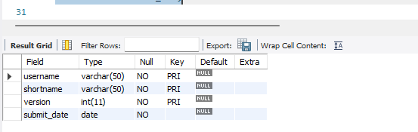

ER Diagram:

